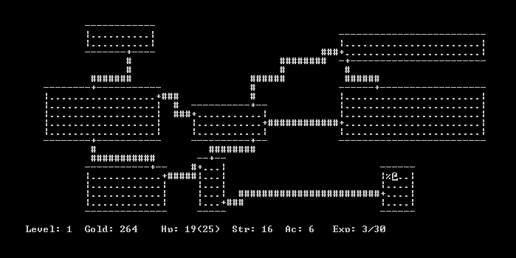Roguelike Research – What are they, and what makes a roguelike?

# *What is a roguelike?*

***Roguelike*** has originally been used to describe games that closely mimic the game “ROGUE” title from 1980’s, but in recent years the term has been used to describe more indie titles which don’t necessarily fit that description, but all must share the two important mechanics:

Randomization - each time player plays the game; the levels must be randomly generated. This also needs to happen when players die.

Figure 1- ROGUE|1980

Permadeath - this means that once player dies, they lose all the progress they have made in the current playthrough and must start over from beginning.

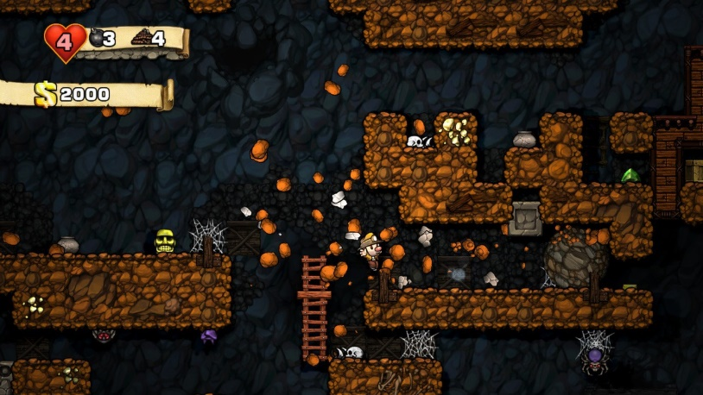A great example of a game that contains permadeath and randomization of levels is Spelunky; in Spelunky each time players start a run, they are placed in a randomly generated mine but each time they start with the same items, the same amount of health, and the same amount of money. This is a true roguelike experience, but in recent years games have made changes to this formula by introducing things like upgrade systems which will give players persistent advantages on each run. Games with such advantages are known as ***“roguelites”***; they are not the true experience of a rogue like game but are rather a “lite” version of the formula.

Figure 2- Spelunky, a true roguelike.

# *Roguelike – Pros & Cons*

*D*ue to the mechanics of a roguelike game, they mostly reward player skill because each run the game is the same and because of this the overall difficulty of the game over time stays the same, and the only way to get better at the game is to improve your own skill. Due to this, a highly skilled player might be able to complete the game with no problems, but a low skilled player might never complete the game unless they improve their skill, but if they keep dying, they will never succeed in the game.

Due to the permadeath nature of a roguelike game, we are not exposed to the same amounts of dopamine once we complete a run; in other games we experience dopamine from being rewarded for our runs, even when we die, but in roguelike games players can essentially feel like they have just wasted their time.

# *Roguelite – Pros & Cons*

*W*ith the permadeath mechanic removed players feel like they are being rewarded, when they die, they are rewarded with experience, items, skills, etc. which improves their chances in succeeding in the next run and giving them a reason to continue. This naturally means that with each run the difficulty of the game is reduced, causing a weird difficulty curve where players first start the game at its hardest, but over time make it more and more easy (which is opposite to most other games).

As example, Dead Cells creates an artificial grind barrier where players must grind to purchase upgrades which will allow them to progress further into the game.

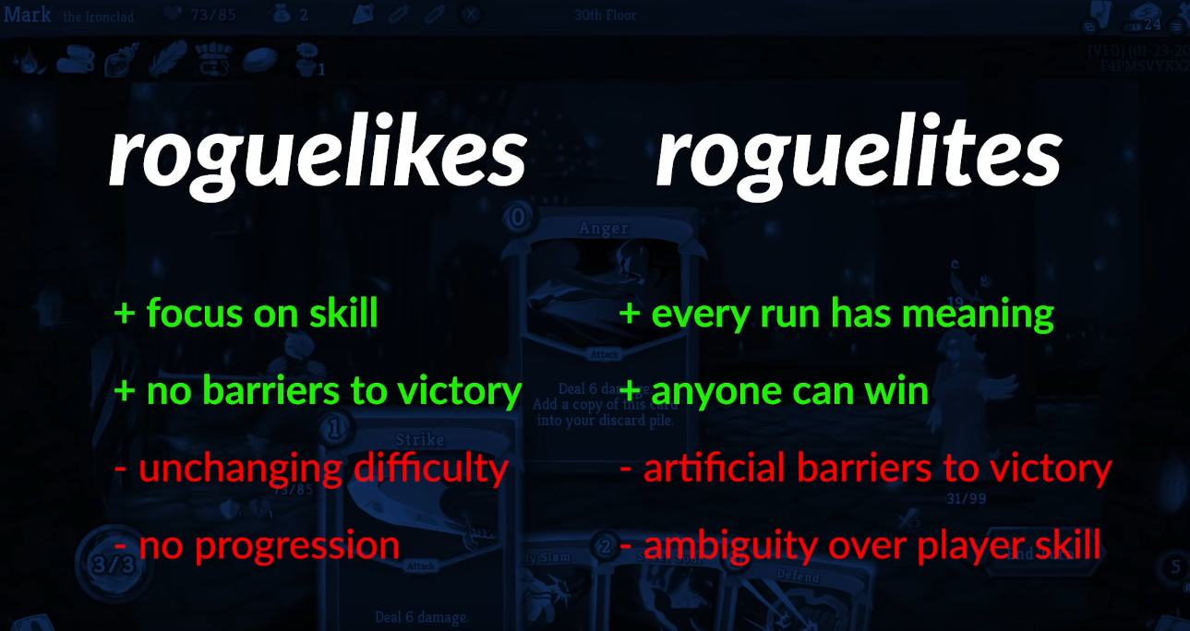

Figure 3- Advantages and disadvantages of roguelikes/roguelites. (RPP - GameMaker'sToolkit, 2019)

*O*ver the year’s designers have found ways of working around those drawbacks, to give players reasons to keep playing. In Enter the Gungeon, each time player kills a boss, they are rewarded with special currency and players can spend those in hub world, but this currency does not unlock new powers for the character, instead it adds new weapons to the pool of weapons that can be randomly dropped. This does not necessarily make the game easier, as those guns are no more powerful than the guns that players already have.

Other games allow players to unlock new characters, which do not make the game easier, as the characters have their own advantages/disadvantages making them balanced compared to the characters which players start with.

And finally, cosmetic unlockables, these do not add any new characters to the table but only new skins. This is an easy way for developers to reward players and keep them keen to play the game again.

# *Initial Idea for Our Game*

In the initial idea that I have proposed on Monday, I described how our game would have roguelike features, permadeath and randomized levels. The levels which players would spawn in, would be randomly generated, but to make it easier to generate the levels we could have set amount of rooms which are used to randomly generate a level.

In the level, players would have 90 seconds (to be discussed, and decided upon) to grind as much experience (or cash, coins, etc.) to purchase upgrades from the shop that opens after 90 seconds. After players have purchased upgrades, they proceed to defeat the boss; this is where the loop repeats, but the enemies are more difficult.

In the game we would have different characters, each with different disadvantages and advantages to make sure they are balanced, but with time (or currency) players would be able to unlock new characters. Players could also unlock new skins for existing characters, to keep them wanting to play more of the game.

This idea still requires more work, but it’s the fundamentals for the game. In this game we would be looking at fast paced, intense fun; ideally, we’d like to see Fiero from the players as they defeat the bosses, to show their triumph in the game.

# *Art style/Themes*

As already mentioned before, the roguelike genre comes from the game Rogue, the game used ASCII characters as the art style; it was simple and worked well. Since the original Rogue, games have expanded and now use different graphics; most of developers use 2D sprites for their games, as they are easy to make and can be created very quickly with a smaller team; the same applies to roguelite games.

Figure - Isometric roguelike game.

In recent years, few roguelikes have used isometric point of view for their games. It an interesting take on roguelike games, as it delivers a different point-of-view to existing top-down roguelike games.

One of the bigger problems of isometric games, are the controls, they can become unclear to the player (what is left, and what is right?).

Another issue is the camera and the walls. If we decided to use 3D models, we’d run into the issue of ‘how should the camera behave when players walk behind a tall wall?’, some games make the wall see-through and some just hide the wall from player’s view. This is something we must think about if we decide with 3D graphics.

While most roguelike games stay close to the original idea, of players making their way through a dungeon killing monsters, some games decided to go in a different theme. The most common theme for a roguelike is the dungeon crawler theme, in this scenario the players are making their way through a dungeon, killing monster and trying to achieve a goal.